# Exploratory Data Analysis of Diwali Sales:

1. Installing python libraries : Numpy, Pandas, Matplotlib, Seaborn
2. Data cleaning and processing using Python :

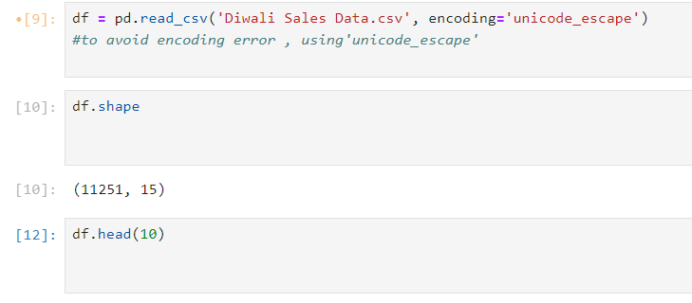

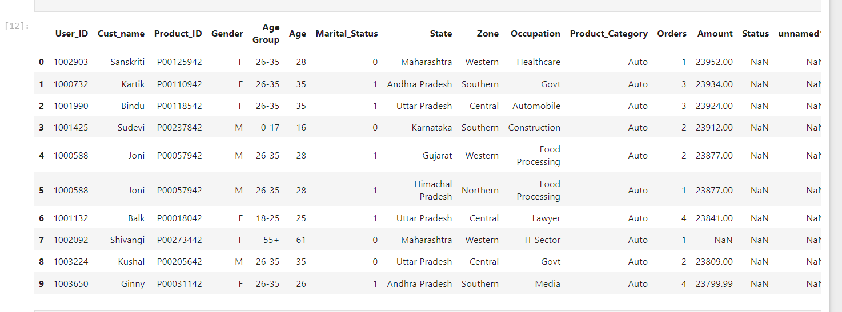

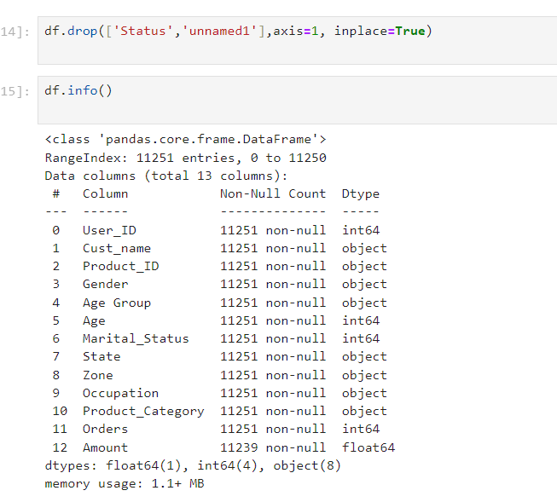

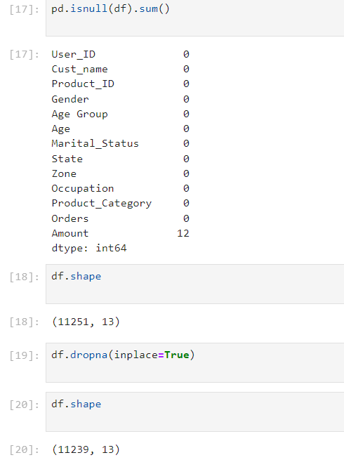

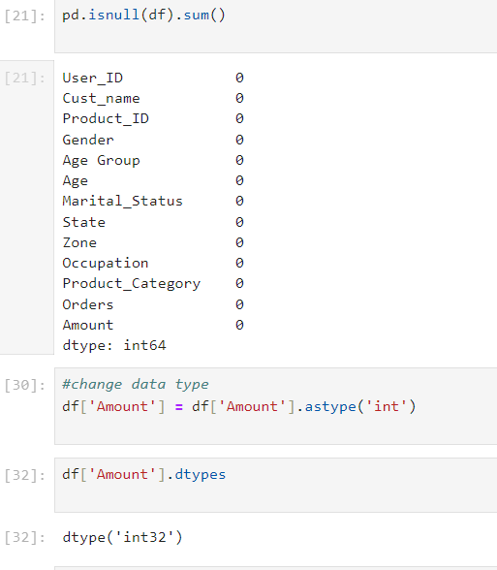

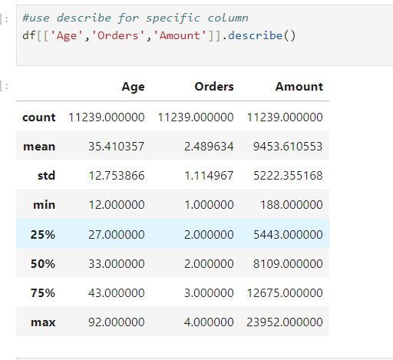

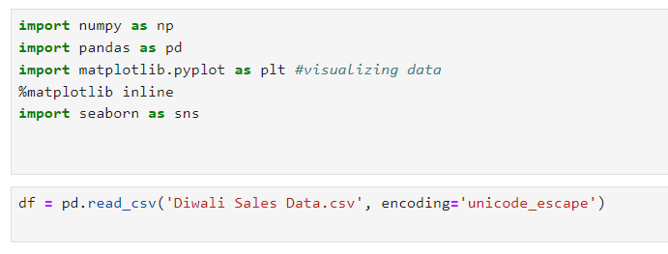

1. Data Analysis and providing insights :

**Gender**

1. 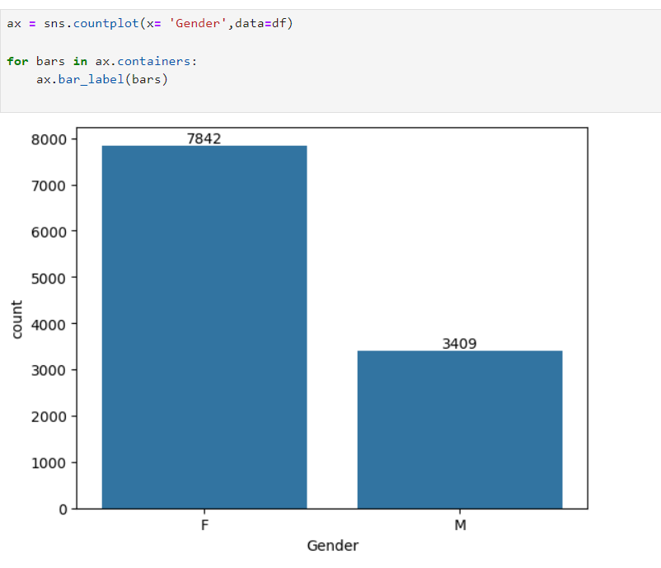

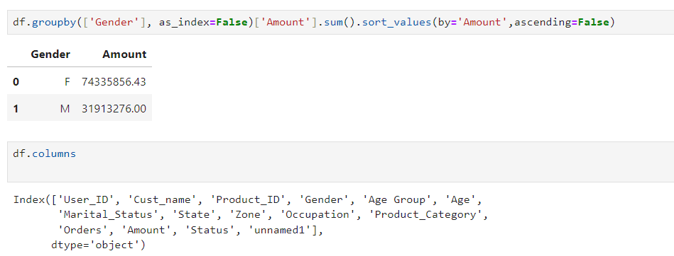

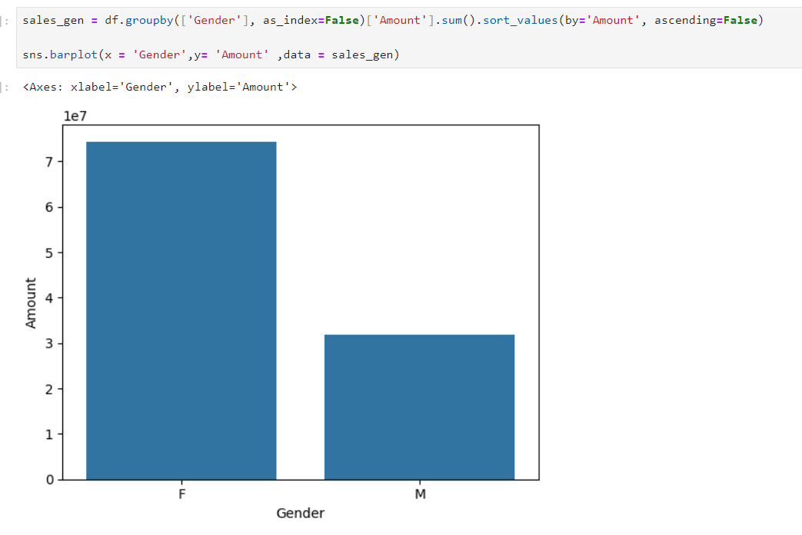

**Insights :** *from the above graphs we can see that the no. of females are more than males and also the amount spend by them is more.*

**Age:**

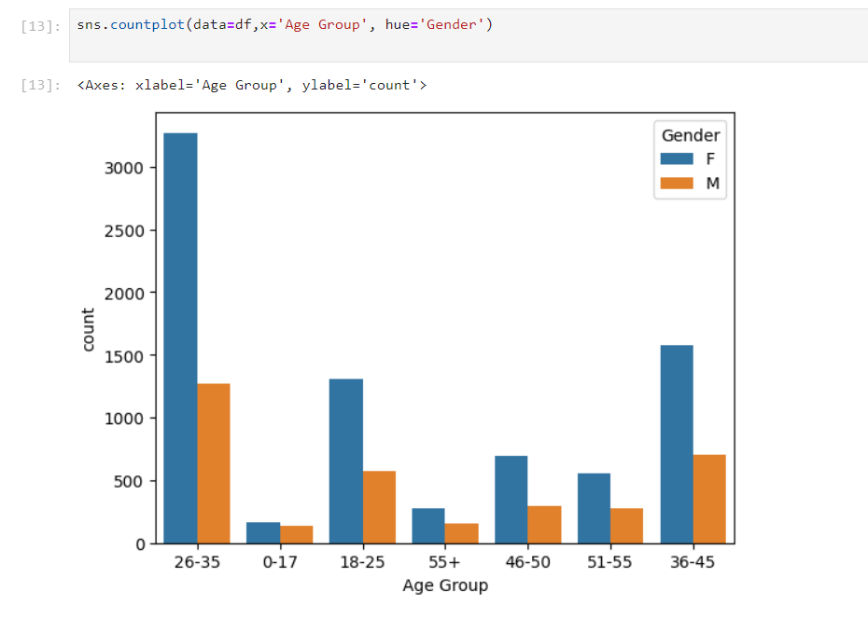

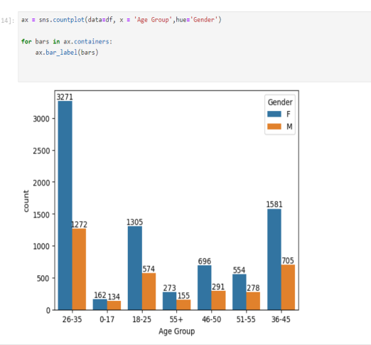

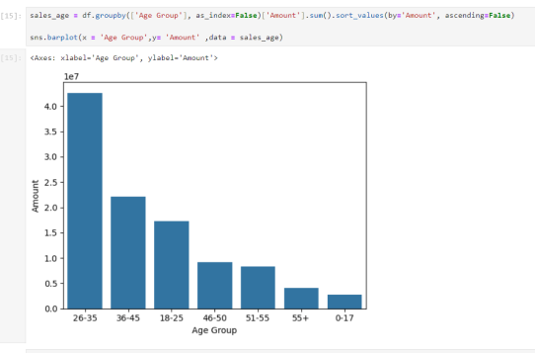

**Insights:** *From the above graphs we can see that most of the buyers are from the age group 26-35 years.*

**State:**

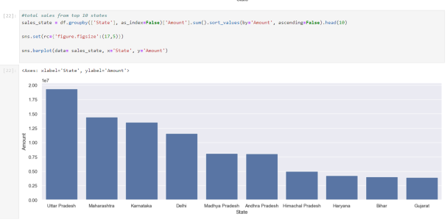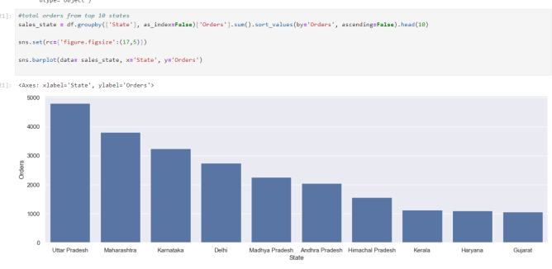

**Insights :** *from the above graphs we can see that most of the orders and sales/amount are from Uttar Pradesh,Maharashtra, and Karnataka respectively.*

**Marital Status:**

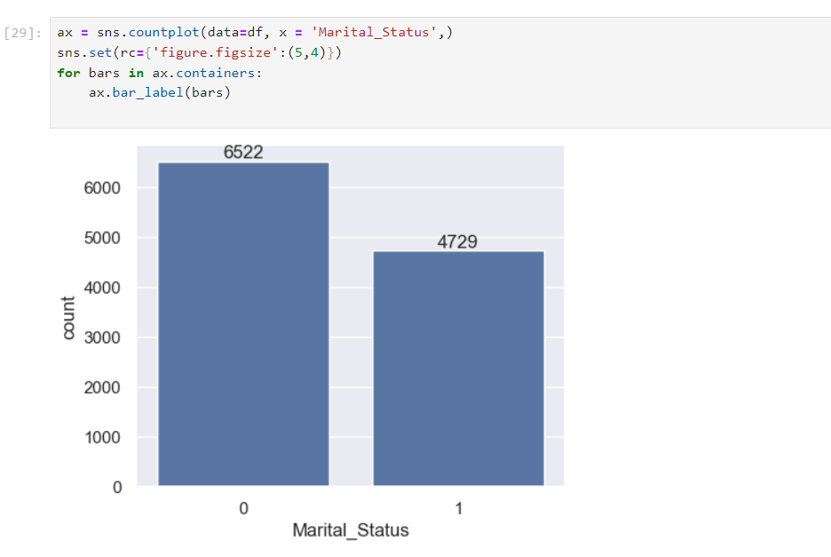

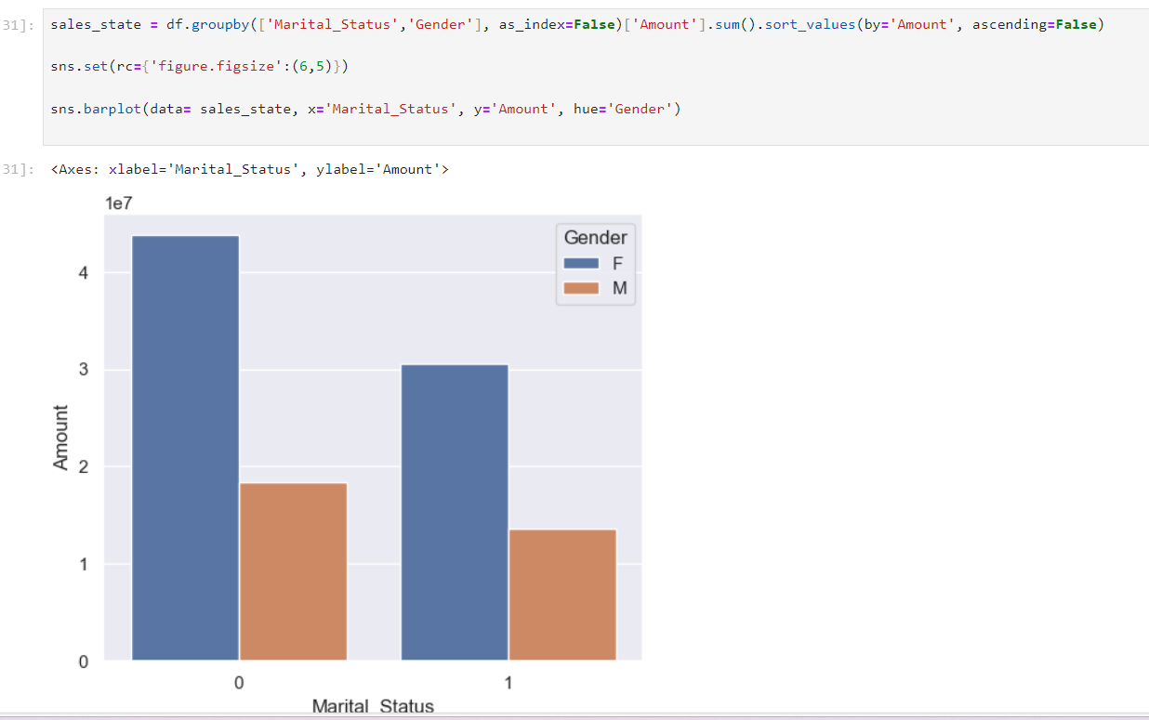

**Insights :** *from the above graphs we can see that most of the buyers are married (Women) and they have high purchasing power*

**Occupation:**

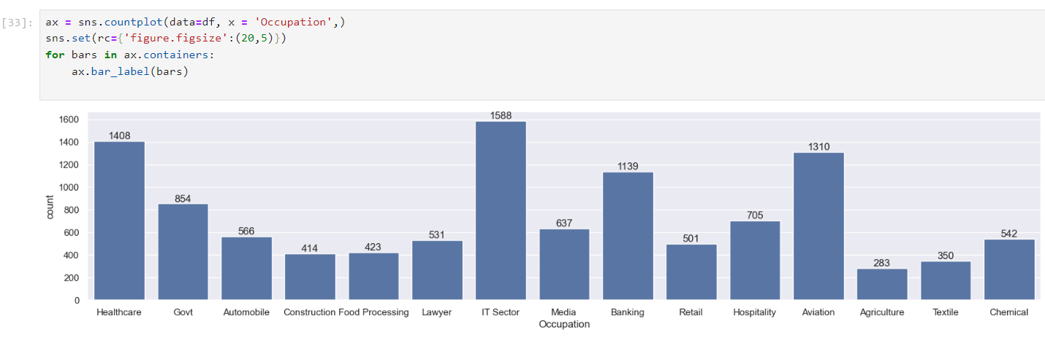

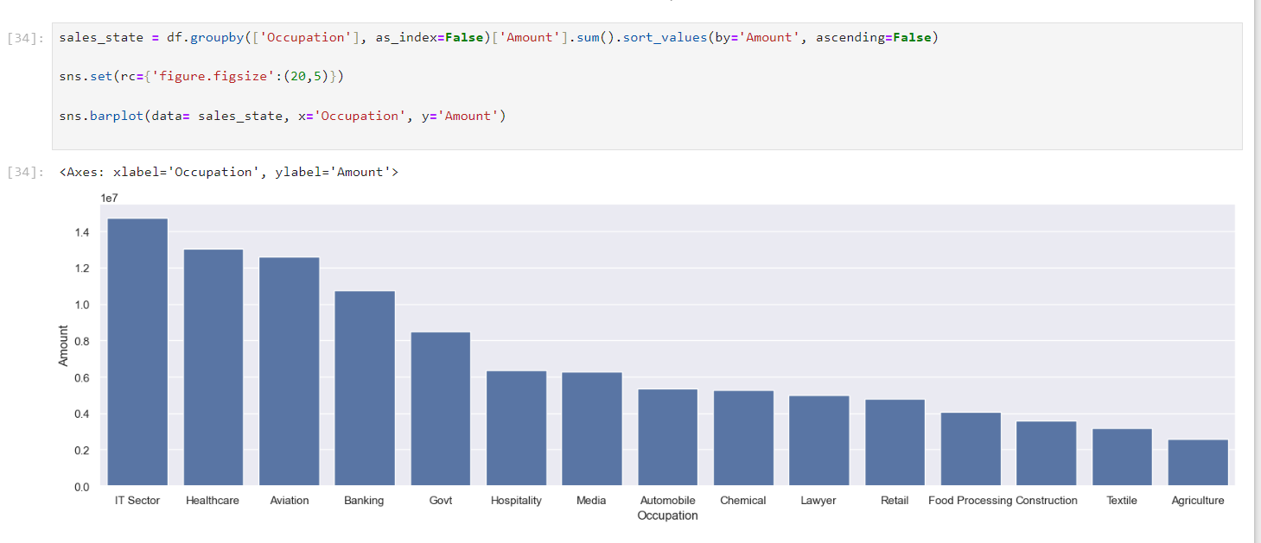

**Insights :** *from the above graphs we can see that most of the buyers are from IT,Healthcare and Aviation.*

**Product Category:**

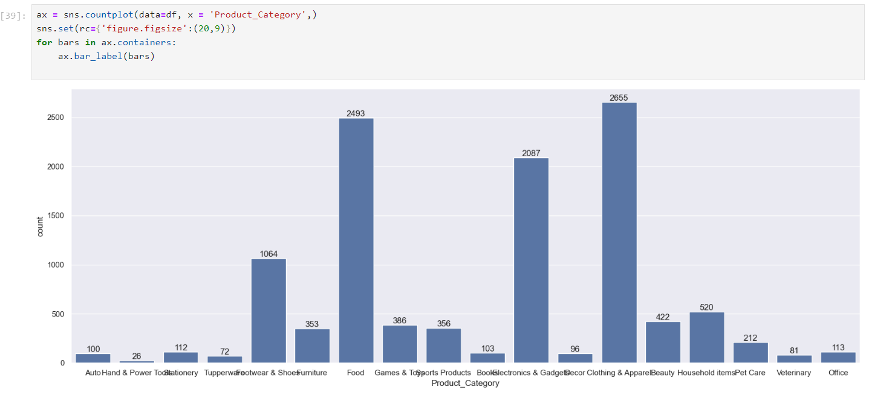

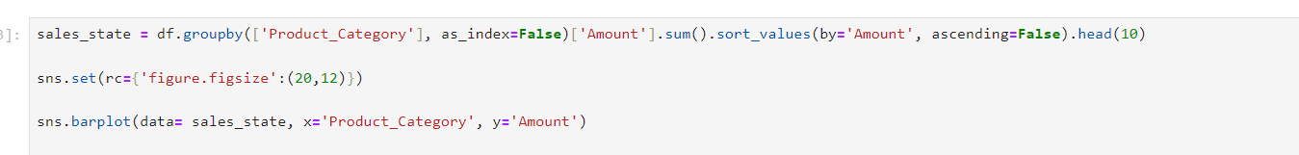

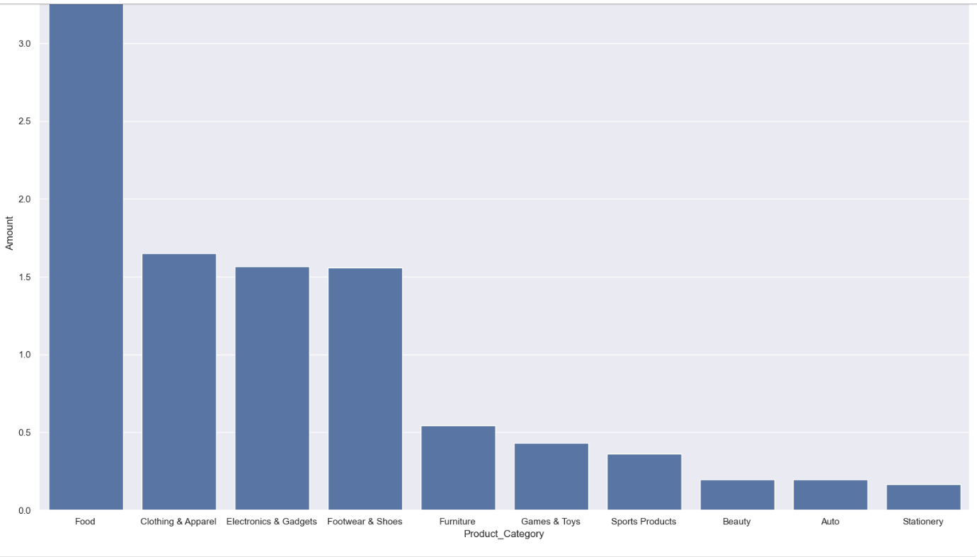

**Insights :** *from the above graphs we can see that most of the sold products are from Food, Footwear,and Electronics category*

***Conclusion :***

***Married women from the age group of 26-35 years from UP,Maharashtra, and Karnataka working in IT, Healthcare,and Aviation are more likely to buy products from Food,Clothing, and Electronics category.***